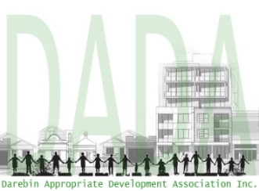
Darebin Appropriate
Development Association
Web: http://www.darebinada.org
Inc. No. A0094111Q

Order form : (mark appropriate box)

Membership $15:

Objectors Guide: $15

Membership & Guide: $20

Donation (optional): $

I _______________________________ wish to become a member of the
Darebin Appropriate Development Association (DADA).

I support the purposes of DADA and agree to comply with the rules.

Signed: _________________________________________

Address: ________________________________________

________________________________________________

Phone: __________________________________________

Email: __________________________________________

Date: ___________________________________________

Please transfer your payment to DADA Bank Account:

Acct Name: Darebin Appropriate Development Association
Bank: Bendigo Bank
BSB: 633000
Acct No: 157516378

Scan & email completed form to: darebinada@gmail.com

For further enquiries, email: darebinada@gmail.com

Please allow a few days for payment to be received and acknowledged.

