IMPORTANT NOTE:
Your objection will be made available for public viewing and copies may be made to interested parties for the sole purpose of enabling consideration and review as part of the planning process under the Planning and Environment Act 1987.
Please print clearly.
WHO IS OBJECTING?
I/We
(Name in block letters)
Owner/s or Occupier/s
(Address)
Our Postal Address: |  |  |  |  |  |  | Postcode:
Telephone No: | #### #### |  |  | EEmail:
WHAT APPLICATION DO YOU OBJECT TO?
What is the permit application number? |  |  |  |  | D/302/2017
What is proposed? |  |  |  |  | Development of a five storey building comprising four (4) apartments, a shop and a reduction in car park, as shown on the plans accompanying the application.
What is the address of proposed development? |  |  |  |  | 655 Plenty Road PRESTON
Who has applied for the permit? |  |  |  |  | john divitkos (site owner), urban edge consultants pty ltd south melbourne
WHAT ARE THE REASONS FOR YOUR OBJECTION?

- The proposal replaces a small shop, with an even smaller shop (51 sq m) and 4 apartments across 4 levels. Land size is 6.1 x 36.6 = 223 sq m, zoned C1Z, and the DDO17 Schedule is applicable.

The proposal is an over development, with smaller apartments 1 and 2 buried deep inside the structure suffering compromised internal amenity.
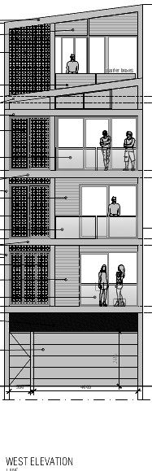 | 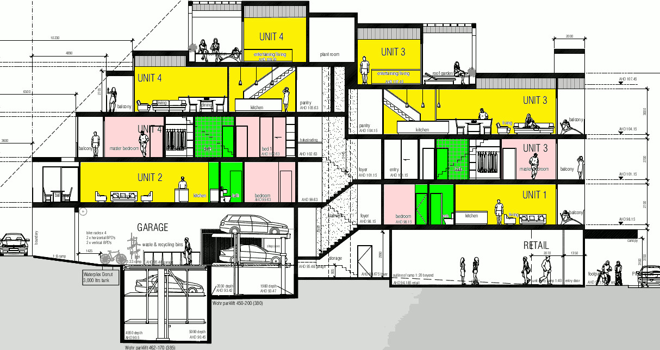 | 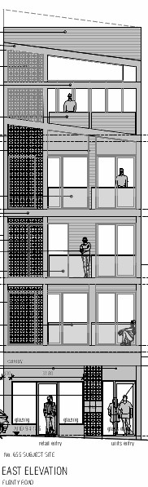
- The site is too narrow to support such a building, leading to compromised internal amenity. Apartments in the Tyler St activity centre require a minimum width of at least 15m, whilst this proposal offers just 6.1 m.

see Schedule 17, section 2.1.1 here
http://planningschemes.dpcd.vic.gov.au/schemes/darebin/ordinance/43_02s17_dare.pdf

2.1.1 Minimum frontage width to Plenty Road
Land should be consolidated as follows to enable higher densities and create favourable
conditions for high quality development outcomes:

- Land to be developed in a Commercial 1 Zone and Mixed Use Zone 1 should have a minimum frontage width of 15 metres.
- Land to be developed in the General Residential Zone or the Residential Growth Zone should have a minimum frontage width of 20 metres.
- Where a development does not achieve the frontage width requirements above, it should demonstrate to the satisfaction of the Responsible Authority how the proposal intends to achieve exemplary design outcomes. Such a development may not be eligible to build to the maximum height.
- The minimum frontage width requirements do not apply to maintenance works to existing buildings, façade works, internal restructuring and ground floor extensions to existing structures or to heritage overlay areas.”

- The property title has a restrictive covenant (c/o Henry Zwar et al 21/06/1926) that protects the land from mining and quarrying activities, except for the purpose of constructing building foundations.
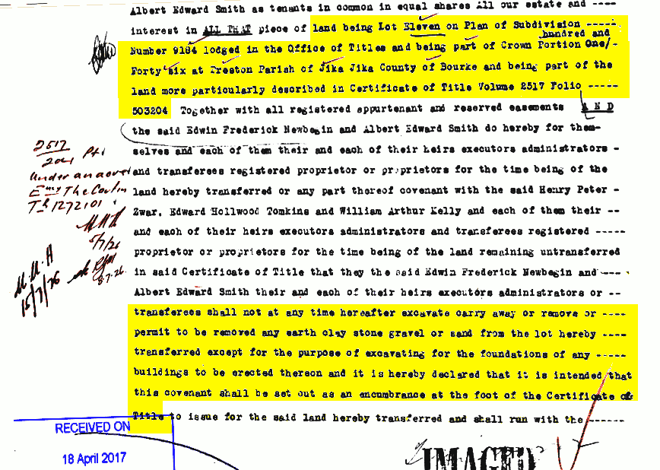
The removal of soil to build a sump for a car stacker conflicts with this covenant.
- Rear access to the site is via a single width laneway that is shared amongst 23 adjoining properties (x6 206-216B Tyler St, x3 at 2-6 Oakhill Ave and x14 545-671 Plenty Rd ). The site is so narrow that it is not possible to turn a vehicle around. The site offers insufficient parking. The lane way is to be shared by vehicles seeking parking, cyclists doing similar, and pedestrians encumbered with rubbish and recycling bins. This is a recipe for conflict and grief amongst users of the laneway, with knock on effects on limited street parking in the nearby residential streets.
- The waste management plan is not stated. It is unclear whether collection involves transferring waste to the front of the site, to the rear, or must use a dedicated waste contractor. We do know that there is insufficient public space at the front and rear of the site to accommodate an extra 10 bins (5x waste and recycling) prior to waste collection.
- Rear access to the site is via a single width laneways that is shared amongst 23 adjoining properties. The site is so narrow that it is not possible to turn a vehicle around on. The site offers insufficient parking, with constrained rear access shared amongst vehicles cyclists and pedestrians to the adjoining 23 properties. This is a recipe for conflict and grief.
- Rear balconies overlook the secluded private open space for house at 2-10 Oakhill avenue, with the biggest losers being number 2 and 4.
- The proposal does not respect the existing or preferred Neighbourhood Character and is not consistent with Clause 22.04 of the Darebin Planning Scheme.
- Taking into account the predominant single story, free standing houses in the immediate vicinity, the proposed application is an overdevelopment for this site.
- The proposal is of sufficient concern to warrant review against the Darebin Planning Scheme by Darebin Planning Committee.
- The visual bulk from the built scale of the proposed development will be very imposing as it will be visible from surrounding properties and the street.
- The proposed development does not add net value to the community.
- The number of objections indicates the scale of the negative social effect on the community.
- The proposed development does not meet standards set in the Darebin Planning Scheme amendments appropriate for this street.
- The proposed development will not guarantee social or affordable housing.
If there is not enough room, attach a separate page

HOW WILL YOU BE AFFECTED BY THE GRANT OF A PERMIT?
- This development will negatively affect the livability of the street and community. Such a large development will destroy the amenity currently enjoyed by surrounding residents and visitors to the area.

IMPORTANT NOTES ABOUT OBJECTIONS TO PERMIT APPLICATIONS
- This form is to help you make an objection to an application in a way which complies with the Planning and Environment Act 1987, and which can be readily understood by the responsible authority. There is no requirement under the Act that you use any particular form.
- Make sure you clearly understand what is proposed before you make an objection. You should inspect the application at the responsible authority’s office.
- To make an objection you should clearly complete the details on this form and lodge it with the responsible authority as shown on the Public Notice – Application for Planning Permit.
- An objection must –
  - State the reasons for your objection; and
  - State how you would be affected if a permit is granted.
- The responsible authority may reject an application which it considers has been made primarily to secure or maintain a direct or indirect commercial advantage for the objector. In this case, the Act applies as if the objection has not been made.
- Any person may inspect an objection during office hours.
- If your objection related to an effect on property other than at your address as shown on this form, give details of that property and of your interest in it.
- To ensure the responsible authority considers your objection, make sure that the authority receives it by the date shown in the notice you were sent or which you saw in a newspaper or on the site.
- If you object before the responsible authority makes a decision, the authority will tell you its decision.
- If despite your objection the responsible authority decides to grant the permit, you can appeal against the decision. Details of the appeal procedures are set out on the back of the Notice of Decision which you will receive. An appeal must be made on a prescribed form (obtainable from the VCAT (Victorian Civil & Administrative Tribunal)) and accompanied by the prescribed fee. A copy must be given to the responsible authority. The closing date for appeals is 21 days of the responsible authority giving notice of its decision.
- If the responsible authority refuses the application, the applicant can also appeal. The provisions are set out on the Refusal of Planning Application which will be issued at that time.

Signature: |  | Date:

