IMPORTANT NOTE:
Your objection will be made available for public viewing and copies may be made to interested parties for the sole purpose of enabling consideration and review as part of the planning process under the Planning and Environment Act 1987.
Please print clearly.
WHO IS OBJECTING?
I/We
(Name in block letters)
Owner/s or Occupier/s
(Address)
Our Postal Address: |  |  |  |  |  |  | Postcode:
Telephone No: | #### #### |  |  | EEmail:
WHAT APPLICATION DO YOU OBJECT TO?
What is the permit application number? |  |  |  |  | D/213/2018
What is proposed? |  |  |  |  | Construct a four (4) storey building with a basement level and rooftop terrace comprised of twenty eight (28) dwellings, a reduction in the car parking requirements and alteration of access to a road in a Road Zone Category 1 as shown on the plans accompanying the application.
What is the address of proposed development? |  |  |  |  | 552-554 and 556-558 Plenty Road PRESTON VIC 3072
Who has applied for the permit? |  |  |  |  | sparecon holdings pty ltd, metropol planning, qing chen & diymansion pty ltd
WHAT ARE THE REASONS FOR YOUR OBJECTION?

The site is RGZ1 (towers) and DDO17 (high density along Plenty Rd). Site area is 1105 sq m. The proposal replaces 2 family homes with zero shops & 28 apartments (2x 1bed + 24x 2bed + 2x 3 bed) across 4 levels. Basements offer 29 parking spaces.

OK for height, setback, building size (<80%), garden size (17%), storage

The following reasons for objection make reference to Schedule 17 to the design and development overlay – Plenty Rd Corridor, the LPPF and VPPS (especially sections 52 (parking) and 58 (apartments 5+ storeys in residential zone), found here
http://planningschemes.dpcd.vic.gov.au/schemes/vpps
http://planningschemes.dpcd.vic.gov.au/schemes/darebin/ordinance/43_02s17_dare.pdf
52.06 Car parking
rules; 1 space to each 1 or 2 bed dwelling, 2 spaces for 3+ bed
1 visitor space to 5 dwellings, need passing space at entry
requires 2+24+4+5=35 spaces, plans show 29 spaces provided by car stackers

INSUFFICIENT PARKING FOR RESIDENTS & VISITORS
52.06-6 Car Parking:
“Applications to reduce the car parking requirement under clause 52.06-5 … must be accompanied by a car parking demand assessment.”

The necessary car parking demand assessment is absent.
52.06-8 design standard 4 - Mechanical parking
“Car parking spaces that require the operation of the system are not allocated to visitors unless used in a valet parking situation”

There is no provision for visitor car parking, as all parking spaces rely upon car stackers.
It is unreasonable and dangerous to expect visitors to use the car stackers.
Disabled car parking
Accommodation is provided for people with limited mobility (14 apartments G03, G04, G05, 104, 105, 106, 107, 204, 205, 206, 207, 301, 302, 303) meeting standard B41 (with respect to entrance width, corridor width to main bedroom , with adaptable living are and bathroom).

52.05-5 “The proportion of spaces to be allocated as disabled spaces must be in accordance with Australian Standard AS2890.6-2009 (disabled) and the Building Code of Australia.”
52.06-8 “Disabled car parking spaces must be designed in accordance with Australian Standard AS2890.6-2009 (disabled) and the Building Code of Australia. Disabled car parking spaces may encroach into an access way width specified in Table 2 by 500mm”

Alas, there is no parking for disabled drivers, and instead they are expected to operate tripple storey car stackers, and navigate the busy basement car park shared with 29 vehicles, waste collection services and cyclists.

It is unreasonable and dangerous to expect disabled residents to use the car stackers.
55.02-3 Dwelling diversity objective
There is an oversupply of 1 and 2 bedroom apartments in Darebin (and Melbourne), and an under supply of 3 or more bedroom separate housing for families. This development adds zero to this imbalance by removing a family home and compensating with just 2x three bedroom apartments.

The situation can be improved by merging those 1 and 2 bed room apartments with poor internal amenity.
55.07-1 Accessibility
Plans are annotated to claim 13 are disability compliant apartments (13x 2 bed and 1x 3 bed, or 50%) yet provides just one small elevator to service 28 apartments across 4 levels .

Is it reasonable to expect upto 29 wheel chairs and 25 able bodies to share a single elevator?
55.07-1 Energy efficiency objectives
It is likely that air conditioning units will be placed on balconies.

It is unclear whether the apartments are equipped with sufficient thermal insulation to achieve standard D6
VPP 55.04-6 Overlooking
To limit views into existing secluded private open space and habitable room windows.

The first floor balconies east facing apatments overlook the secluded private open space of theexisting dwellings at 27-31 Kitchener St with direct views into habitable rooms

The objective and design standard is not met
55.07-6 Noise impacts objectives
The site is adjacent to a busy road and tram route 86. It is doubtful whether any acoustic attenuation is incorporated into the design.

It is questionable as to whether the habitable rooms over-looking the Plenty Rd achieve the acoustic noise levels specified in the design standard.
55.07-11 Waste and recycling
A small waste store is provided in the basement. It is unclear whether this store offers space for waste segregation or bin washing. There is no loading bay for the waste and recycling collection. Internal circulation to and from the waste room is the via space shared shared with vehicles and bicycles. The waste management facilities are inadequate and unworkable.

The objectives and design standard are not met.
VPP 55.07-9 Private open space above ground
Standard B43

A dwelling should have private open space consisting of:
An area of 15 square metres, with a minimum dimension of 3 metres at a podium or other similar base and convenient access from a living room, or
A balcony with an area and dimensions specified in Table B8 and convenient access from a living room.

If a cooling or heating unit is located on a balcony, the balcony should provide an additional area of 1.5 square metres.

Table B8 Balcony size
Dwelling Type | Minimum Area | Minimum dimension
Studio or 1 bedroom dwelling | 8 square metres | 1.8 metres
2 bedroom dwelling | 8 square metres | 2.0 metres
3 or more bedroom dwelling | 12 square metres | 2.4 metres

Apartments 102-108, 202-208, 302, 303 amd 305 (i.e., 17 of 28 or 61%) offer balconies with dimensions 2.55x3.0=7.7 sq m that are below the minimum size of 8.0 sq m. It is likely that an airconditione runit will be placed on each bacony, removing another 1.5 sq m of usable space.

The objective and design standards are not met
55.07-6 Noise impacts objectives – standard B40

The layout of new dwellings and buildings should minimise noise transmission within the site.
Noise sensitive rooms (such as living areas and bedrooms) should be located to avoid noise impacts from mechanical plants, lifts, building services, non-residential uses, car parking, communal areas and other dwellings.

New dwellings should be designed and constructed to include acoustic attenuation measures to reduce noise levels from off-site noise sources.

Buildings within a noise influence area specified in Table B6 should be designed and constructed to achieve the following noise levels:
Not greater than 35dB(A) for bedrooms, assessed as an LAeq,8h from 10pm to 6am.
Not greater than 40dB(A) for living areas, assessed LAeq,16h from 6am to 10pm.

The bedrooms of G03, G05, G06 and G07 are directly over the car stackers
Apartments 108, 208 and 305 have a bed room adjacent with the lift shaft

The apartment design fails to minimise noise transmission form internal mechanical plant to noise sensitive rooms such as bedrooms.

There is no evidence as to whether the building incorporates any acoustic damping measures to achieve the prescribed noise levels for bedrooms and living areas.

The objectives and design standard are not met

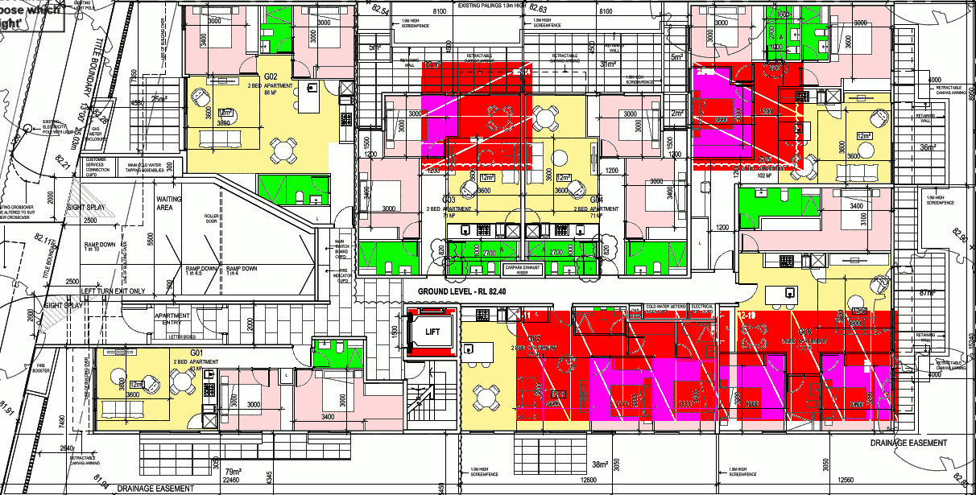

55.07-12 Functional layout objective – standard B46
To ensure dwellings provide functional areas that meet the needs of residents.
Living areas (excluding dining and kitchen areas) should meet the minimum internal room
dimensions specified in Table B11.

Table B8 Balcony size
Dwelling Type | Minimum width | Minimum area
Studio or 1 bedroom dwelling | 3.3 metres | 10 sq m
2 or more bedroom dwelling | 3.6 metres | 12 sq m

2 bed apartments 101 and 201 have kitchens that extend into the corridor

The objectives and design standard are not met
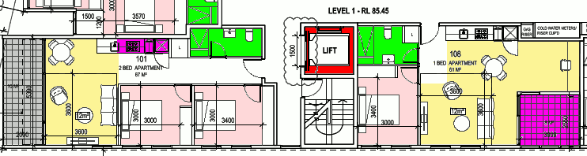
If there is not enough room, attach a separate page

HOW WILL YOU BE AFFECTED BY THE GRANT OF A PERMIT?
- This development will negatively affect the livability of the street and community. Such a large development will destroy the amenity currently enjoyed by surrounding residents and visitors to the area.

IMPORTANT NOTES ABOUT OBJECTIONS TO PERMIT APPLICATIONS
- This form is to help you make an objection to an application in a way which complies with the Planning and Environment Act 1987, and which can be readily understood by the responsible authority. There is no requirement under the Act that you use any particular form.
- Make sure you clearly understand what is proposed before you make an objection. You should inspect the application at the responsible authority’s office.
- To make an objection you should clearly complete the details on this form and lodge it with the responsible authority as shown on the Public Notice – Application for Planning Permit.
- An objection must –
  - State the reasons for your objection; and
  - State how you would be affected if a permit is granted.
- The responsible authority may reject an application which it considers has been made primarily to secure or maintain a direct or indirect commercial advantage for the objector. In this case, the Act applies as if the objection has not been made.
- Any person may inspect an objection during office hours.
- If your objection related to an effect on property other than at your address as shown on this form, give details of that property and of your interest in it.
- To ensure the responsible authority considers your objection, make sure that the authority receives it by the date shown in the notice you were sent or which you saw in a newspaper or on the site.
- If you object before the responsible authority makes a decision, the authority will tell you its decision.
- If despite your objection the responsible authority decides to grant the permit, you can appeal against the decision. Details of the appeal procedures are set out on the back of the Notice of Decision which you will receive. An appeal must be made on a prescribed form (obtainable from the VCAT (Victorian Civil & Administrative Tribunal)) and accompanied by the prescribed fee. A copy must be given to the responsible authority. The closing date for appeals is 21 days of the responsible authority giving notice of its decision.
- If the responsible authority refuses the application, the applicant can also appeal. The provisions are set out on the Refusal of Planning Application which will be issued at that time.

Signature: |  | Date:

