IMPORTANT NOTE:
Your objection will be made available for public viewing and copies may be made to interested parties for the sole purpose of enabling consideration and review as part of the planning process under the Planning and Environment Act 1987.
Please print clearly.
WHO IS OBJECTING?
I/We
(Name in block letters)
Owner/s or Occupier/s
(Address)
Our Postal Address: |  |  |  |  |  |  | Postcode:
Telephone No: | #### #### |  |  | EEmail:
WHAT APPLICATION DO YOU OBJECT TO?
What is the permit application number? |  |  |  |  | D/843/2017
What is proposed? |  |  |  |  | Development of six (6) dwellings ranging from 2 to 3 storeys above and behind the existing shop to be retained and a reduction to the car parking requirement, as shown on the plans accompanying the application.
What is the address of proposed development? |  |  |  |  | 295-297 Gilbert Road PRESTON
Who has applied for the permit? |  |  |  |  | architectural plans and permits thornbry and safet suljovic
WHAT ARE THE REASONS FOR YOUR OBJECTION?

The site is RGZ and the proposal replaces family home behind the milk bar (49 sq m) with 6 apartments (1x 1 bed, 2x 2 bed, 3x 3 bed) across 3 levels. The ground offers 5 single garages and one uncovered parking space, with no loading bay. Site area is 637 sq m.

Ground floor plans show 3 disguised bedrooms labeled with the word “retreat”. The dwelling yield is maximised whilst avoiding obligations to provide sufficient parking for the residents, visitors and shop. We should be simply saying NO to this ambit claim instead of wasting our valuable time with this extended reviewing process.

Reasons for rejection follow with reference to the LPPF and VPPS can be found here
http://planningschemes.dpcd.vic.gov.au/schemes/vpps
especially sections 52 (parking) and 55 (apartments 1-4 storeys in residential zones).
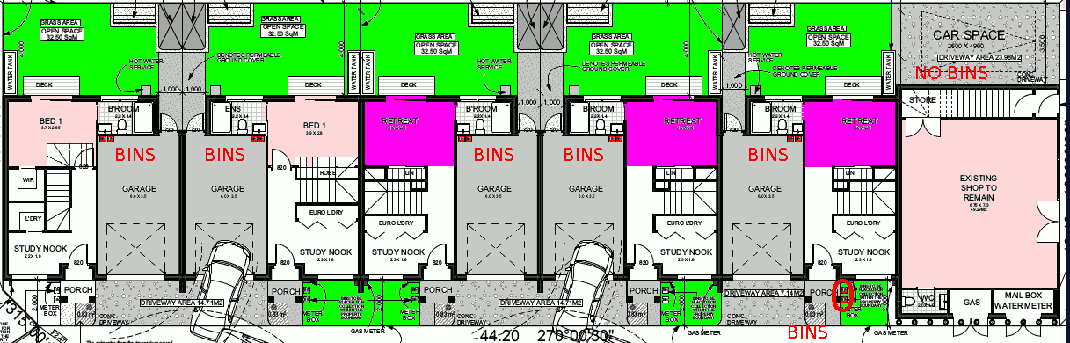
Ground floor plans show bed rooms disguised as “retreat” with door to be added later, undersize bed rooms, insufficient parking, bins in garages, A1 bins in A2 yard and none for the shop.
- Car parking [LPPF 52.06]
Rules; 1 space to each 1 or 2 bed dwelling, 2 spaces for 3+ bed, 1 visitor space each 5 dwellings, shops need loading bay, and parking space
Requires 3 + 6 + 1 + 1 = 11 spaces, yet the plans show 6 spaces.
Insufficient car parking for residents, visitors and the shop
- Car Parking: VPP 52.06-6 “Applications to reduce the car parking requirement under clause 52.06-5 … must be accompanied by a car parking demand assessment.”
The necessary car parking demand assessment is absent.
- Infrastructure [VPPS 58.02-4] Developments should not exceed the capacity of … infrastructure including roads.
Access [VPPS 58.03-6] The development is adjacent to the no parking clearway on Regent St, and offers insufficient parking for residents, visitors and the shop. The Access objectives and design standard are not met.
- Loading and unloading of commercial vehicles [LPPF 93.11]
The mixed use development includes 1 shops (49 sq m) but does not provide a loading bay. There are no nearby alternatives as Regent St has parking and clearway restrictions, whilst the single carriage laneway services 5 garages and adjacent properties.
- Undersize bed rooms 3.9x2.8 m, (ground floor for apartments 5 and 6, and the disguised bedrooms for apartements 2, 3, 4) do not comply with minimum sizes specified 55.07-12 functional layout (i.e., 3.0x3.4 m for main bed room 3.0x3.0 m for all other bedrooms). The objectiove and design standard D10 are not met
- Energy efficiency objectives: [VPPS 55.07-1] Plans show air conditioning units placed on their balconies. It is unclear whether the apartments are equipped with sufficient thermal insulation to achieve standard B35,
- Noise impacts objectives [55.07-6]: The site is adjacent to a busy road and tram route 11. It is doubtful whether any acoustic attenuation is incorporated into the design. It is questionable as to whether the habitable rooms over-looking Regent St achieve the acoustic noise levels specified in the design standard.
- Waste and recycling [VPPS 55.07-11] Bins are to be stored in garages. Except Apartment 1 has no garage, so its bins are show in the yard of Apartment 2, and the shop gets no waste or reccling bins The waste management facilities are inadequate and unworkable.
The objectives and design standard are not met.
If there is not enough room, attach a separate page

HOW WILL YOU BE AFFECTED BY THE GRANT OF A PERMIT?
- This development will negatively affect the livability of the street and community. Such a large development will destroy the amenity currently enjoyed by surrounding residents and visitors to the area.

IMPORTANT NOTES ABOUT OBJECTIONS TO PERMIT APPLICATIONS
- This form is to help you make an objection to an application in a way which complies with the Planning and Environment Act 1987, and which can be readily understood by the responsible authority. There is no requirement under the Act that you use any particular form.
- Make sure you clearly understand what is proposed before you make an objection. You should inspect the application at the responsible authority’s office.
- To make an objection you should clearly complete the details on this form and lodge it with the responsible authority as shown on the Public Notice – Application for Planning Permit.
- An objection must –
  - State the reasons for your objection; and
  - State how you would be affected if a permit is granted.
- The responsible authority may reject an application which it considers has been made primarily to secure or maintain a direct or indirect commercial advantage for the objector. In this case, the Act applies as if the objection has not been made.
- Any person may inspect an objection during office hours.
- If your objection related to an effect on property other than at your address as shown on this form, give details of that property and of your interest in it.
- To ensure the responsible authority considers your objection, make sure that the authority receives it by the date shown in the notice you were sent or which you saw in a newspaper or on the site.
- If you object before the responsible authority makes a decision, the authority will tell you its decision.
- If despite your objection the responsible authority decides to grant the permit, you can appeal against the decision. Details of the appeal procedures are set out on the back of the Notice of Decision which you will receive. An appeal must be made on a prescribed form (obtainable from the VCAT (Victorian Civil & Administrative Tribunal)) and accompanied by the prescribed fee. A copy must be given to the responsible authority. The closing date for appeals is 21 days of the responsible authority giving notice of its decision.
- If the responsible authority refuses the application, the applicant can also appeal. The provisions are set out on the Refusal of Planning Application which will be issued at that time.

Signature: |  | Date:

