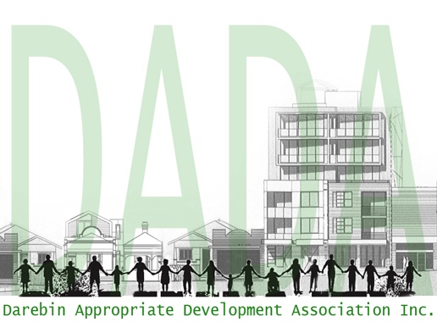
Darebin Appropriate
Development Association:
Protect Your Community
Inc. No. A0094111Q

Web: http://www.darebinada.org

Email us at darebinada@gmail.com

Agenda: 7pm 13 March 2018

We acknowledge DADA is meeting on Wurundjeri country and pay our respects to elders past and present.

Present: Jessica Doyle, Chris Erlandsen, Maria Poletti, Anne Laver, Mandy Baird

Apologies: Stuart Midgley, Cathy and Kevin Audley, Meryl Waugh, Sally Mendes

Business Arising:
- Membership receipts were sent for those who renewed their membership or joined. Membership fee received from Nola Martin. Membership forms were also sent to new members.
- Letter prepared for candidates in the Batman by-election on 17 March 2018. No official response from either candidates. Alex did ring and left a message to meet, but we have not met.
- Feedback from meet and greet with Ged Kearney on 23 February 2018. Standard lounge room meeting with candidate. Nothing to report on housing and planning.
- Meeting with Susan Rennie 27/2. Met at 2:45 was for 2:30. Call it in process, no timeline as such and DADA should review it. Cladding audit. Increase in NRZ from 11% to more, “No real benefit to increase in NRZ”. GRZ has a discretionary maximum building height of 13.5 metres (approx. 3 storeys), Council could vote to make it higher. DADA will respond to Susan seeking follow up on outstanding items from the meeting.
- Meeting with CEO will happen 11/4.
- Meeting re Preston Market 9/3 for 3pm Victorian Planning Authority. Informal discussion to begin with. One representative from Council and none from Planning. Danielle Feiland from Small Business. They are meeting with other community groups. DADA’s response on the Market has been posted on the website. Requesting the Minister to call in the Planning Applications for Preston Market was made. Waste management, drop off and pick up parking zone was also raised. 31 July 2018 submissions to the Minister. Community reference group will be established. We will talk to the Save our Preston Market group and that they be represented on the group. Anne met with Gaetano and Marion re Save our Preston Market. The website notes and the link is here for https://vpa.vic.gov.au/project/preston-market-site for those who wish to comment and contribute.

- Questions to Council – Maria asked a question about cladding to Council and asked about whether or not Darebin Council has conducted an audit of buildings? The Council responded the VBA is responsible for audit and risk process, similar to Yarra and Moreland, they have identified 48 buildings for review they have been approved by private surveyors. Council concerned about uncertainty surrounding the matter. The VBA only inspected high-rise buildings. Darebin Council has not addressed the issue of low-rise cladded buildings. Follow up question did the audit include any buildings under 25 metres that didn’t have sprinklers? – Chris asked about the review of the planning scheme, Municipal Strategic Statement? Vague response was provided by the Mayor, it would appear the Council is stalling in its response and Chris awaits a written response.

- Reminder when asking questions at Council, please only ask on behalf of DADA if the questions have been discussed at DADA, otherwise please ask as an individual.

- New Business:
  - Save our Preston Market Group status and involvement with DADA. Jessica to email Marion to seek if the Group still requires the auspice of DADA and use thereof the Incorporated Number, if so membership fees of $15 now due, otherwise removal of the incorporated number from the website and Facebook. (Later added note: Lori-anne Sharp confirmed they will keep Inc number and pay fees.)
  - Definitions of a Market – for the purpose of the amendment definition established:
Market definition:
An open place or covered but not enclosed building, where buyers and sellers convene regularly for the sale of goods, predominantly fresh food and for the strengthening of community bonds.
Shop definition:
An enclosed building or part of an enclosed building where goods or services are sold. A shop has four walls and a doorway entrance.
Stall definition:
An open stand, booth, or compartment for the sale of goods in a market or large covered area. Work will continue on these definitions. Chris will write to John Casey to define “net community benefit”.
  - Batman How to Vote Card from DADA determined and decided. Maria to post on website and Jessica to send out how to vote card to email list. (See attached to this email)
  - Zoning – A question to be asked again about increasing the percentage of NRZ? Chris to ask about Darebin Council making a public submission to the VPA regarding Preston Market.
  - Review of the Call it in Process – meeting with Susan Rennie prompt Council to review by sending them our review, Maria to develop points to discuss at next meeting.
  - Agenda for meeting with CEO – raise the issue of review of the Call it in Process, the NRZ increase, the 200m, audits of houses in Darebin questions to be determined out of session.

- From the press:
  - N/A
- Objector Updates: 3 storey development in Reservoir without parking Mendip Rd Corner of Storey Rd.

- Other Business:
  - N/A

Next Meeting: 7.00pm, Tuesday the 17th of April 2018 due to school holidays at 572 Plenty Road, Preston (Corner of Josephine Grove).

