Number D/548/2014/A
Date 24/12/2015
Location 708-710 High Street RESERVOIR VIC 3073
Description Construct an additional two (2) dwellings * Reduce the car parking requirement associated with the proposed new dwellings; as shown on the plans accompanying the application.
Type Amended Plans/Permit
Officer Marisia Hammerton

land size 539 sq m (details found via http://gis.darebin.org)
see https://www.google.com.au/maps
WHO ikonimides reid

Summary Replace milk bar and family home with 1x 1 bed + 1x 2 bed + 4x 3 bed
relies upon open plan kitchen/meals/living (KML)
L2; 1 bed (U1-4)
L1: KML + 1 bed (U6), KML (U1-4), KML + 2 bed (U5)
GND : Cafe, 1 bed + 3rd bed disguised as"home office" (U1-4)
P: 5 spaces
No buildings over easements (not shown)
U1-4 HAS THIRD BEDROOM DISGUISED AS "HOME OFFICE"
POOR INTERNAL AMENITY FOR U5 AND U7
INSUFFICIENT PARKING
no loading bay for cafe

Parking http://planningschemes.dpcd.vic.gov.au/schemes/vpps/52_06.pdf
requires 8 spaces, rule is 2 space to each 3 or more bed dwelling
requires 2 spaces, rule is 1 space to each 1 or 2 bed dwelling
requires 1 space, rule is 1 visitor space per 5 dwelllings
requires ? space for cafe staff
requires >11 in total, and plans show 5 spaces

HOW TO OBJECT
++++++++++++
(1) objection form first page, top half, add your name and contact details with
“phone number=WITH HELD, communication from the developer is to be in writing ”
(2) last page, lower section, add your name or signature and todays date
(3) Send to Darebin town planning by email, fax, mail or in person
Post to: PO BOX 91 Preston 3072
Fax 8470 8877 ATTENTION: TOWN PLANNING
email: townplanning@darebin.vic.gov.au

HOW TO ENCOURAGE NEIGHBOURS TO OBJECT
+++++++++++++++++++++++++++++++++++++
(1)Print and or photocopy multiples of the resident letter (below) plans and objection form.
available herehttp://www.darebinada.org/category/objections
(2) Walk surrounding streets. If you knock on doors you can discuss the proposal and get neighbours to sign the objection on the spot. Alternatively you can drop the information in their letterbox and follow up with a visit later.
(3) Send to Darebin town planning by email, fax, mail or in person
Post to: PO BOX 91 Preston 3072. Fax 8470 8877 ATTENTION: TOWN PLANNING
++++++++++++++++++++++++++
email: townplanning@darebin.vic.gov.au
subject: Objection to D/548/2014/A 708-710 High Street RESERVOIR VIC 3073
+++++++++++++++++++++++++
Dear Darebin Planning
Please find attached an objection to this planning proposal.
Yours Sincerely

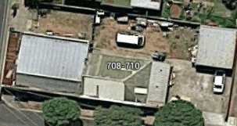

N
/ \
|

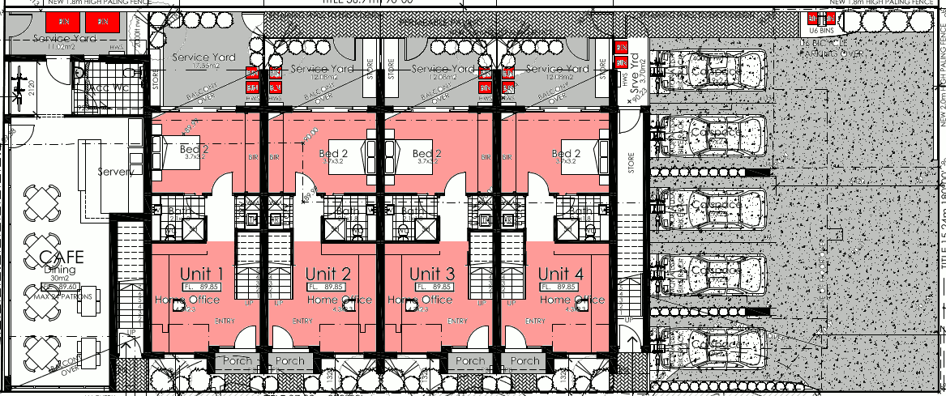
GND D/548/2014/A 708-710 High Street RESERVOIR VIC 3073
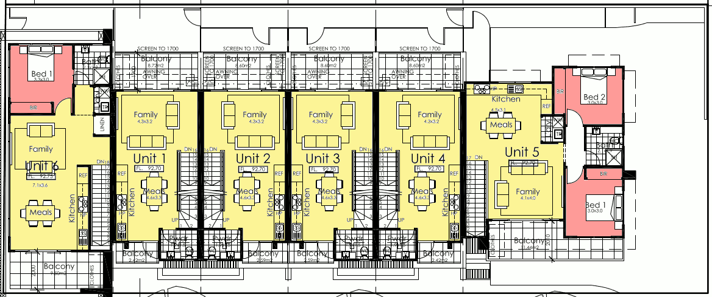
L1 D/548/2014/A 708-710 High Street RESERVOIR VIC 3073
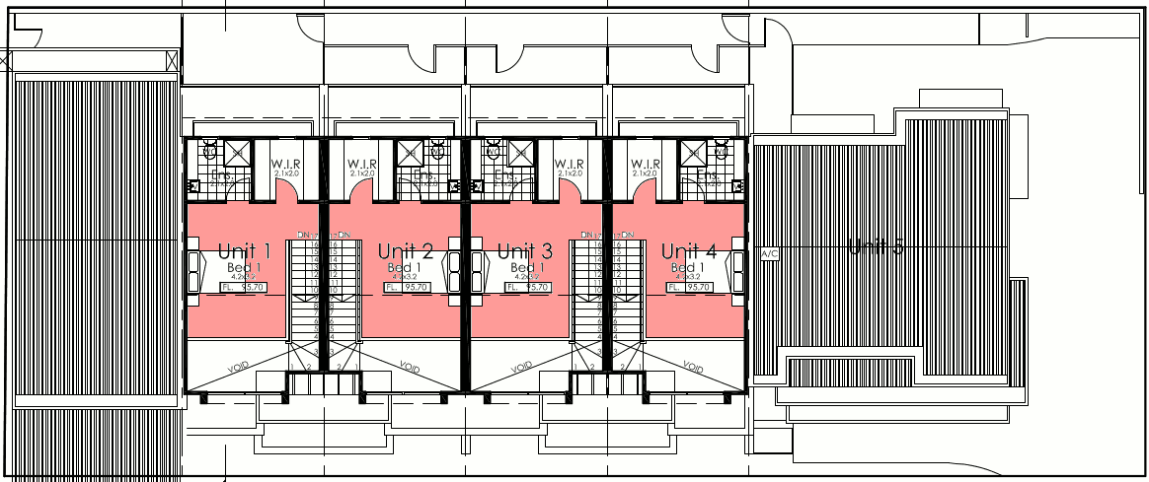
L2 D/548/2014/A 708-710 High Street RESERVOIR VIC 3073
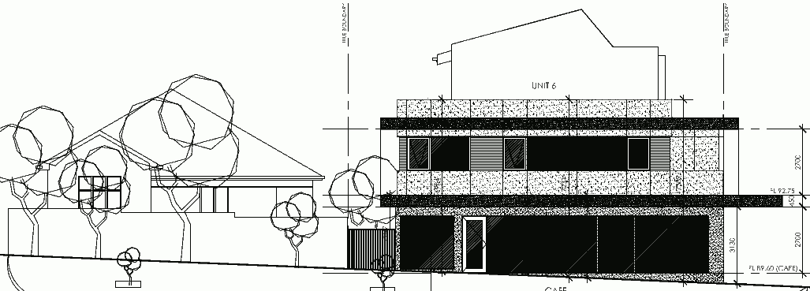
N ←-- from HIGH ST D/548/2014/A 708-710 High Street RESERVOIR VIC 3073
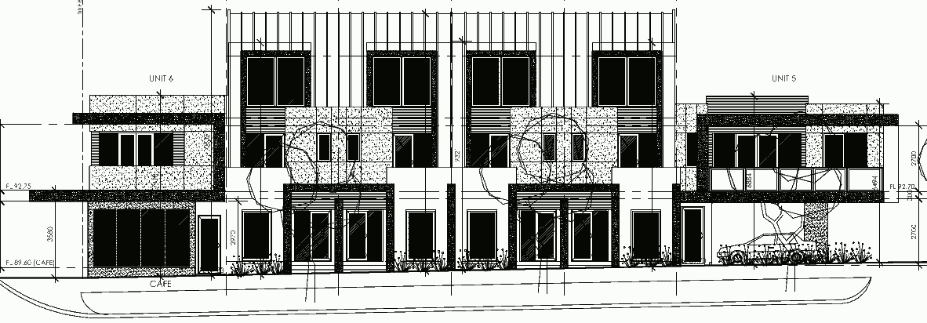
FROM MASON ST D/548/2014/A 708-710 High Street RESERVOIR VIC 3073

