Number D/939/2015
Date 12/11/2015
Location 314-6 St Georges Road THORNBURY VIC 3071
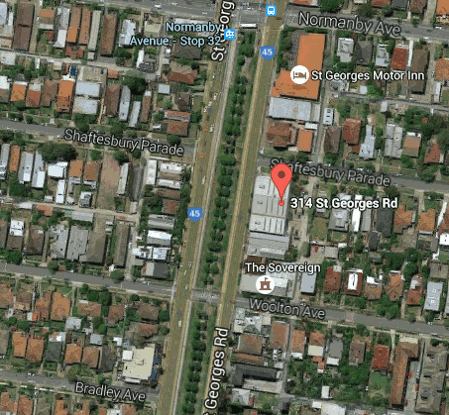
Description Use and development of the land for the purpose of a 5-storey development comprised of four (4) commercial tenancies, one (1) restaurant and 46 dwellings; a reduction in the car parking requirement and waiver of the loading bay requirement, as shown on the plans accompanying the application.
