Number D/458/2015
Date 29/06/2015 5:49:41 PM
Location 830 Plenty Road RESERVOIR VIC 3073
Description Mixed use development comprising 3 to 12 storey buildings with 326 dwellings, 962sqm of office in ten tenancies, 106 bicycle spaces and 401 car spaces, use of land for dwellings, reduction in the standard car parking requirement and other matters as shown on the plans accompanying the application.
Status Advertising Completed
Type Mixed Use Development

land size 18,130 sq m (details found via http://gis.darebin.org)
see https://www.google.com.au/maps

Summary Former Summerhill IGA, Medical Centre, Chemist and Pub carpark are
replaced by (22%) 73 x1 bed, (64%) 209x 2 bed, (8%) 27x 3 bed apts
and (5%) 17 x 3 bed town houses = 326 dwellings,
plus ten (small) office spaces (total 962 sq m), and 401 car spaces
See the plans for evidence of a very high apartment yield
Poor internal amenity for 1 bed apts (< 50 sq m.) & 2 bed apts are not much better

Parking http://planningschemes.dpcd.vic.gov.au/schemes/vpps/52_06.pdf
requires 88 spaces, rule is 2 space to each 3 or more bed dwelling
requires 282 spaces, rule is 1 space to each 1 or 2 bed dwelling
requires 65 spaces, rule is 1 visitor space to each 5 dwellings
? for 10 office spaces (total 962 sq m)
requires >435 in total, and plans show 401 spaces = INSUFFICIENT PARKING
NO LOADING BAYS FOR RETAIL
AND REDUCED PARKING FOR SUMMERHILL PUB PATRONS

WHO architeria and partners pty ltd, 3/110 doncaster rd, doncaster

HOW TO OBJECT
++++++++++++++++
(1) objection form first page, top half, add your name and contact details with
“phone number=WITH HELD, communication from the developer to be in writing ”
(2) last page, lower section, add your name or signature and todays date
(3) Send to Darebin town planning by email, fax, mail or in person
Post to: PO BOX 91 Preston 3072
Fax 8470 8877 ATTENTION: TOWN PLANNING
email: townplanning@darebin.vic.gov.au

HOW TO ENCOURAGE NEIGHBOURS TO OBJECT
+++++++++++++++++++++++++++++++++++++
(1)Print and or photocopy multiples of the resident letter (below) plans and objection form.
available herehttp://www.darebinada.org/category/objections
(2) Walk surrounding streets. If you knock on doors you can discuss the proposal and get neighbours to sign the objection on the spot. Alternatively you can drop the information in their letterbox and follow up with a visit later.
(3) Send to Darebin town planning by email, fax, mail or in person
Post to: PO BOX 91 Preston 3072. Fax 8470 8877 ATTENTION: TOWN PLANNING
++++++++++++++++++++++++++
email: townplanning@darebin.vic.gov.au
subject: Objection to Number D/458/2015 830 Plenty Road RESERVOIR VIC 3073
+++++++++++++++++++++++++
Dear Darebin Planning
Please find attached an objection to this planning proposal.
Yours Sincerely

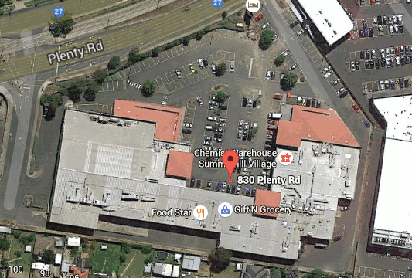
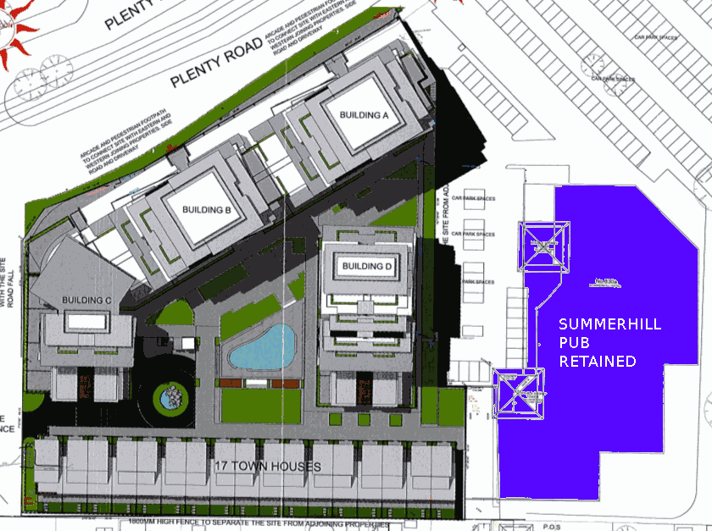
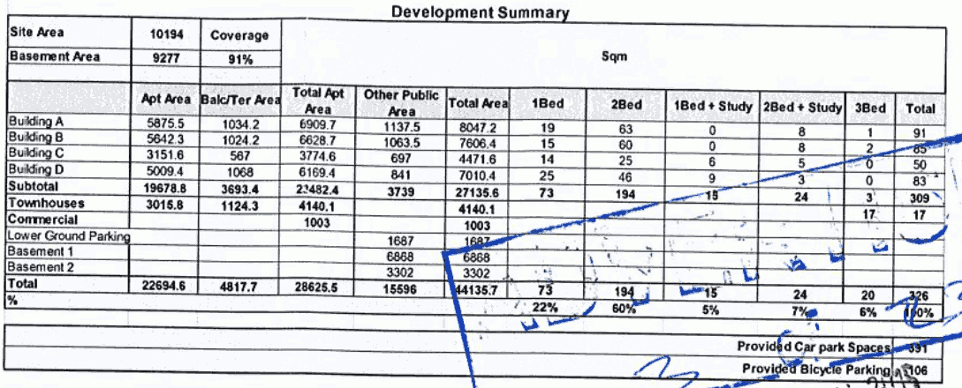

D/458/2015 830 Plenty Road RESERVOIR VIC 3073
Table 1 Summary of the apartment yield.
 | 1 bed | 2 bed = 2b + 1b&study | 3 bed = 3b + 2b & study
A | 19 | 63 = 63 + 0 | 9 = 8 + 1
B | 15 | 60 = 60 + 0 | 10 = 8 + 2
C | 14 | 31 = 25 + 6 | 5 = 5 + 0
D | 25 | 55 = 46 + 9 | 3 = 3 + 0
Town houses | - | - | 17 = 17 + 0
total | 73 | 209 = 194 + 15 | 44 = 41 + 3

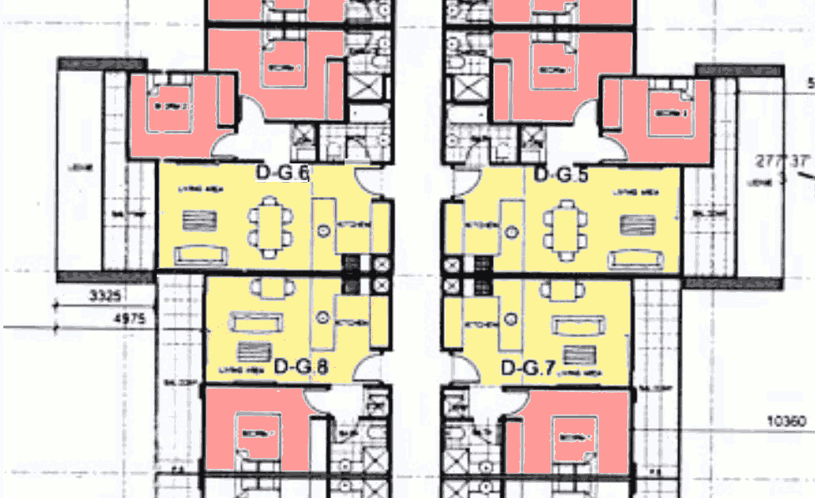
1 bed apt approx 6.5x7.0 ~ 45 sq m 2 bed apt approx 9.2x6.6 = 60 sq m
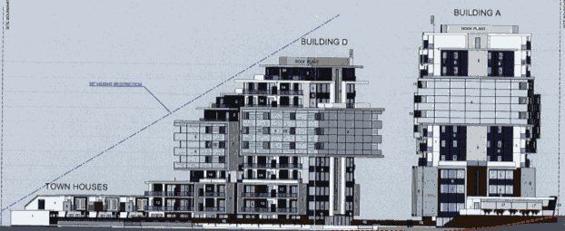
Summerhill rd north side (view from Coles) Plenty rd
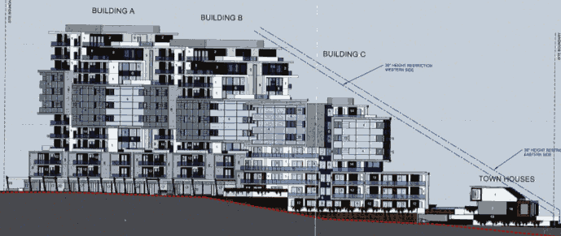
Plenty rd south side (view from Albert St) summerhill rd
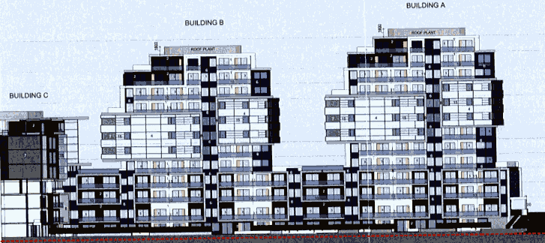
Albert St East side (From Summer hill rd) ----> N

