People for Preston Market

We live here, we shop here and we vote here!

Vision

Preston Market is a unique and treasured place in our community. It has long been a spot where people from Melbourne’s north gather for the pleasures of shopping and eating, a place to enjoy chance encounters with friends and neighbours. It’s looking a little tired and worn but last month’s proposal to build it up to 28 storeys is way over the top. We would like to see the market grow into a vibrant community hub where people come together – not a soul-less windswept shadowland that we avoid. Redevelopment is an opportunity to make Preston Market a showcase site for Darebin – a community space that will attract people from all over Melbourne and beyond. We can make it a meeting place we can be proud of that reflects what we love about our neighbourhood: diversity, inclusiveness, vibrancy, colour and movement.

Who are we?

People for Preston Market is a group of Darebin residents concerned about the plan to increase the building height of the market to 28 storeys – that’s more than 100m!

Membership of the group is open. To join us contact Jim Buckell at jimbuckell@gmail.com or 0415 490 366.

We plan to meet before council meetings (every second Monday) until further notice to lobby councillors and put our ideas on the table.

Like us on Facebook: https://www.facebook.com/groups/554340934669993/

Background on the developer’s proposal

The application to Darebin Council by the market owner Salta Properties to increase the permitted height of buildings under the planning schedule from 10 to 28 storeys was tabled at council on June 16 2014. Council is expected to consider the application soon, probably in August, when it will open a consultation period for submissions. Details of the Salta proposal can be found in the council minutes here (scroll to page 35).

The proposal includes two large footprints of 28 storeys (about 113 metres) taking up the majority of the site. See image below:

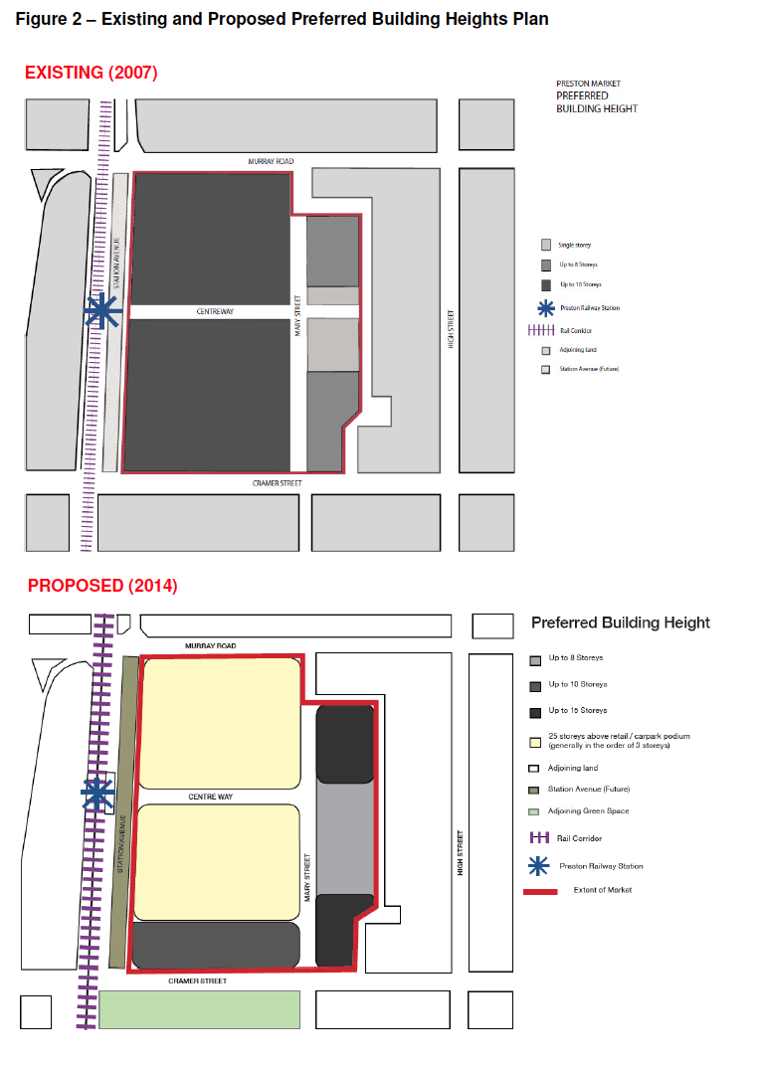

NB: This is not a development application. It is the first step towards a detailed development proposal.

What we would like to see

At our first meeting we set three aims:

- Keep the existing height limit
To oppose any increase in the existing height limit of 10 storeys. This is three storeys higher than the tallest building in Preston, Bell City on Bell St at the corner of Hotham St at South Preston.

- To develop and promote our own vision for the market
A place where people in our diverse community can gather for shopping, meeting, for eating and drinking with welcoming, inclusive and accessible facilities including:

- A market which strengthens and amplifies all the good aspects of the existing space, with ample space for stallholders, shoppers, communal eating and meetings places
- Green space (critically important with the shift to more medium-density housing)
- A commitment to sustainability and renewable energy built into the proposal (ie solar panels on the roof like South Melbourne market; rainwater collection; and waste minimisation)
- Formal and informal meeting places including a neighbourhood centre
- Play areas for children
- Performance and art spaces
- Space for small and micro-businesses to operate
- Open space such as a plaza
- Any proposal for residential units to include social housing to protect our diverse community

- To work with council and other agencies on a visionary market development:
As Preston Market is a unique and treasured place in our community, we would like Council and government agencies to work with all stakeholders – the community, the market traders and the developers – on the development of the site. We would like to take the opportunity of a development proposal to make Preston Market a showcase site for Darebin, a place that will attract people from all over Melbourne, a meeting place we can be proud of that reflects what we love about our neighbourhood. True, the market is looking a bit tired and worn. We’ve been hearing about the idea to transform Preston Central for almost a decade now, and it’s overdue. But we don’t want to risk it becoming a windswept shadowland. We would like to see the market grow into a diverse, vibrant and colourful community hub where people gather to enjoy the pleasures of shopping, food and meeting others. To achieve this, we would like council to consider the following:

- Extending the usual one-month consultation period to six months to consider the application by the developers
- Developing an extensive community consultation program to canvas all stakeholders: residents; shoppers; traders; nearby businesses and workers; commuters; and the developer
- Engage the expertise of experienced placemakers and community planners to assist in this process

Founding members:
Rose Ljubicic
Reservoir
0408 952 713

Maria Poletti
Darebin Appropriate Development Association
9478 6608

Preston

Jim Buckell
Thornbury
0415 490 366

Mark Tregonning
Preston
0421 335 775

To join us contact Jim Buckell at: jimbuckell@gmail.com or 0415 490 366

